University of British Columbia

Electrical and Computer Engineering
Electrical and Computer Engineering Laboratory II
EECE259

DE2-8052 Soft-Core: Getting Started Guide
Copyright © 2008-2011, Jesus Calvino-Fraga

Introduction
This document provides step by step instructions on how to build, load, and run user code in an 8052 soft-core processor configured for the Altera DE2 board.

Configuration Steps
These configuration steps need to be executed only once:

- Download the Quartus II project files for the 8052 soft-core from the course WebCT page. All the required files are compressed in the file ‘DE2_8052.zip’. Decompress all files in a folder of your choice. If you are using the laboratory computers, remember to decompress the files in a folder into your network drive Z:

- Start Quartus II. Open the project ‘DE2_8052.qpf’.

- You may skip this step if you want, as the configuration file ‘DE2_8052.pof’ is already included in the project. Otherwise, in Quartus II click ‘Processing’ → ’Start Compilation’. It may take a few minutes for Quartus II to finish synthesizing the DE2-8052 processor.

- Connect the Altera DE2 to the computer using the USB cable. Change SW19 from ‘RUN’ to ‘PROG’. Turn on the Altera DE2 board.

- To download the configuration file to the Altera DE2 board click ‘Tools’ → ’Programmer’. In the line where the file ‘DE2_8052.pof’ is, make sure the selection box ‘Program/Configure’ is checked. Then press the ‘Start’ button. A moving progress bar shows that the Altera DE2 board is being configured with the 8052 soft-core. Be patient. This usually takes several seconds. Note: In Quartus II version 9.0, it takes a long time for the bar to start moving!

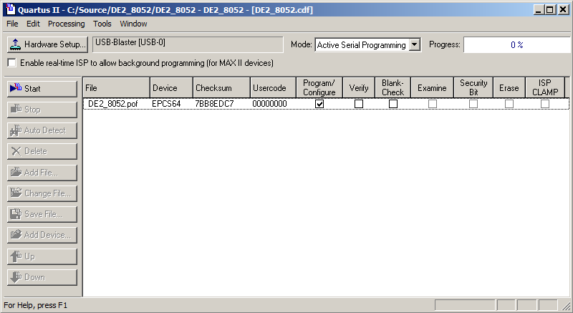

- When the configuration completes change SW19 from ‘PROG’ to ‘RUN’. The DE2-8052 soft-core processor is now loaded in the Altera DE2 board.

Compiling and Loading Programs into the DE2-8052

The DE2-8052 soft-core processor includes a boot loader that can be used to load and run user programs with the DE2-8052. Before doing that, we need to write and compile our program:

- Download and install Crosside from the course web page. Crosside is a text editor with assembly and C syntax highlighting. It also includes a module to transmit files to the DE2-8052 processor.

- Download and Install Call51 from the course web page. Call51 is a C compiler, assembler, linker and librarian for the 8051 family of processors.

- Start Crosside. Create a new assembly file by clicking ‘File’->’New’->’Asm source file’. Type your assembly program and save it. The figure below shows an assembly program saved as ‘blinky.asm’.

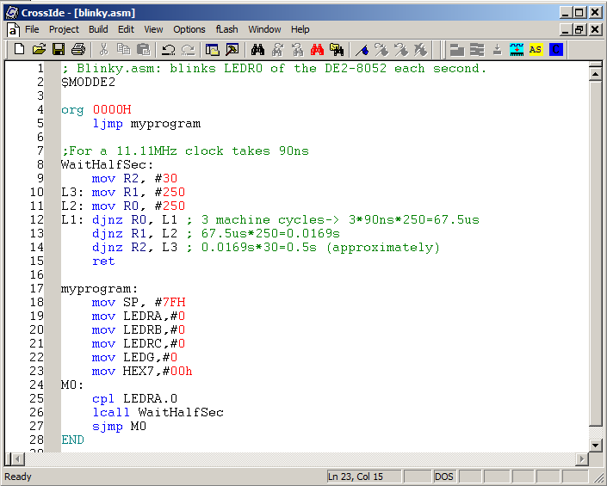

- To compile the program click ‘Build’->’ASM51’. A pop-up window appears. Click the first ‘Browse’ button and find the program ‘a51.exe’ in the ‘bin’ folder of your Call51 installation:

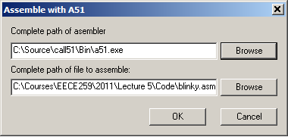

Click ‘OK’. If your program has no errors you can proceed to the next step. Otherwise you need to fix the errors and try again.

- After compiling your source file, a new file with the same name and extension ‘.HEX’ is generated. This is the file we load or ‘flash’ into the DE2-8052 soft-core processor. To do that we need to activate the boot-loader in the DE2-8052 by following this very simple steps:

  - Press and hold KEY1.
  - While holding KEY1, press and release KEY0.
  - Release KEY1.

You will know when the boot-loader is running if LEDG0 is on and all other LEDs are off. In Crosside press ‘fLash’->’DEx-8052’. Make sure the field ‘Port’ is set to ‘USB-Blaster’. (Of course you need to keep the computer connected to the DE2 board with the USB cable!) Press ‘Flash’. Wait until the program finishes.

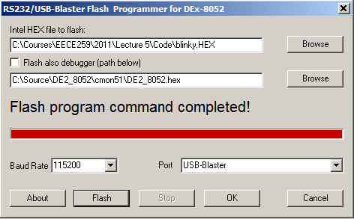

- KEY0 is configured as the Reset button for the DE2-8052. Press KEY0 and your program starts running.

DE2-8052 Soft-Core Special Function Registers (SFRs)

The 8052 soft-core includes all the standard 8052 SFRs. Some additional SFRs were added to provide access to some of the resources in the Altera DE2 board. These are the additional SFRs:

SFR | Address | Description
HEX0 | 91H | Seven segment display 0
HEX1 | 92H | Seven segment display 1
HEX2 | 93H | Seven segment display 2
HEX3 | 94H | Seven segment display 3
HEX4 | 8EH | Seven segment display 4
HEX5 | 8FH | Seven segment display 5
HEX6 | 96H | Seven segment display 6
HEX7 | 97H | Seven segment display 7
LEDRA | E8H | LEDs LEDR0 to LEDR7 (bit addressable).
LEDRB | 95H | LEDs LEDR8 to LEDR15.
LEDRC | 9EH | LEDs LEDR16, LEDR17, and LEDG8.
LEDG | F8H | LEDs LEDG0 to LEDG7 (bit addressable).
SWA | E8H | Switches SW0 to SW7 (bit addressable).
SWB | 95H | Switches SW8 to SW15.
SWC | 9EH | Switches SW16 and SW17.
KEY | F8H | KEY1=KEY.1, KEY2=KEY.2, KEY3=KEY.3.
LCD_CMD | D8H | Bit7 | Bit6 | Bit5 | Bit4 | Bit3 | Bit2 | Bit1 | Bit0
LCD_CMD | D8H | X | X | X | Blon | ON | RS | EN | RW
LCD_DATA | D9H | Input/output port to LCD
LCD_MOD | DAH | Write 0FFH to make LCD_DATA an output
P0MOD | 9AH | Input/Output mode bits for port 0
P1MOD | 9BH | Input/Output mode bits for port 1
P2MOD | 9CH | Input/Output mode bits for port 2
P3MOD | 9DH | Input/Output mode bits for port 3

Pin Assignments
All the standard 8052 I/O pins are assigned to the expansion headers of the Altera DE2 board. By default all the port pins (P0 to P3) are configured as inputs. To configure any of the pins of a port as an output write 1 to the corresponding bit in the PxMOD register described above. For example to make P0.0 and P0.7 outputs and leave P0.1 to P0.6 as inputs, write 81H to P0MOD. These are the pin assignments:

 | JP1
Not used | 1 | 2 | Not used
Not used | 3 | 4 | Not used
Not used | 5 | 6 | Not used
Not used | 7 | 8 | Not used
Not used | 9 | 10 | Not used
5V | 11 | 12 | GND
Not used | 13 | 14 | Not used
Not used | 15 | 16 | Not used
Not used | 17 | 18 | Not used
Not used | 19 | 20 | Not used
Not used | 21 | 22 | Not used
Not used | 23 | 24 | Not used
Not used | 25 | 26 | Not used
Not used | 27 | 28 | Not used
3.3V | 29 | 30 | GND
Not used | 31 | 32 | Not used
Not used | 33 | 34 | Not used
Not used | 35 | 36 | Not used
T0 | 37 | 38 | T1
T2 | 39 | 40 | T2EX

 | JP2
P0.0 | 1 | 2 | P0.1
P0.2 | 3 | 4 | P0.3
P0.4 | 5 | 6 | P0.5
P0.6 | 7 | 8 | P0.7
P1.0 | 9 | 10 | P1.1
5V | 11 | 12 | GND
P1.2 | 13 | 14 | P1.3
P1.4 | 15 | 16 | P1.5
P1.6 | 17 | 18 | P1.7
P2.0 | 19 | 20 | P2.1
P2.2 | 21 | 22 | P2.3
P2.4 | 23 | 24 | P2.5
P2.6 | 25 | 26 | P2.7
P3.0 | 27 | 28 | P3.1
3.3V | 29 | 30 | GND
P3.2 | 31 | 32 | P3.3
P3.4 | 33 | 34 | P3.5
P3.6 | 35 | 36 | P3.7
INT0 | 37 | 38 | INT1
Not Used | 39 | 40 | Not used

